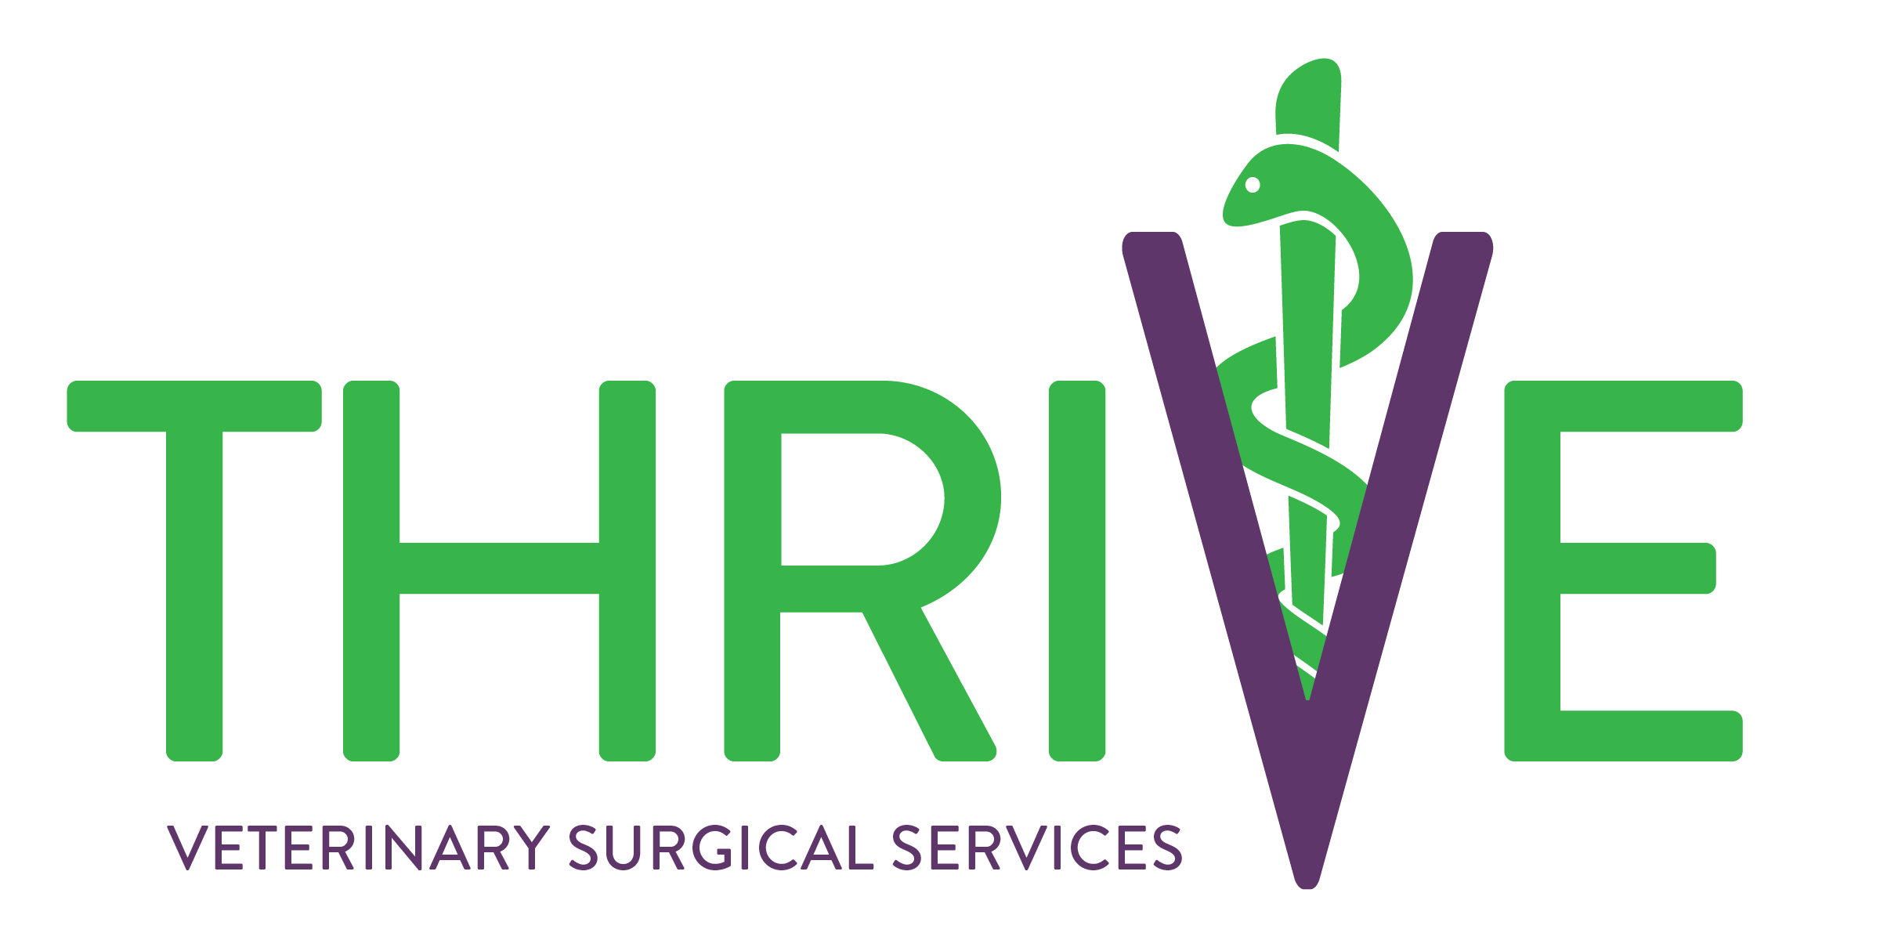

Client/Clinic Cancellation Policy for Thrive Veterinary Surgical Services

Thank you for trusting Thrive to be a part of the healthcare team for your beloved pet. Our time is valuable and so is yours. To ensure we can continue to provide the best service, timely care to all pets, and reduce the impact that last minute schedule changes have on both Thrive and the host clinic, a cancellation policy has been developed and is outlined below.
- The following situations may be subject to a cancellation fee as listed:
  - Consults/rechecks cancelled with < 24 hrs notice (not including weekends) or no-shows – full price of the Thrive consult/recheck
  - Surgeries cancelled with < 1 wk notice – 25% of the low end of the Thrive estimate
  - Surgeries cancelled with < 48 hrs notice (not including weekends) - 50% of the low end of the Thrive estimate
  - Surgeries cancelled with < 24 hrs notice (not including weekends) or no-shows - 100% of the low end of the Thrive estimate

- As Thrive’s estimate is only part of the total estimate provided to clients for surgical services, please ask your host clinic if you would like to know the exact amount of Thrive’s portion.

- All cancellation fees will be billed to the host clinic in the same manner as appointments and surgeries. The host clinic will request payment from clients as indicated.

- Please be aware that some host clinics may ask clients to leave a deposit ahead of surgical services in case a cancellation fee is charged.

- This cancellation policy is for Thrive alone and does not reflect any cancellation policies that host clinics may have.
We understand that life happens, and we will try to accommodate all schedule changes as best we can. If you do need to cancel or reschedule your appointment, please contact both Thrive Veterinary Surgical Services (907-931-8139) and the host clinic via phone.

____________________________________________________________
Client signature/date

