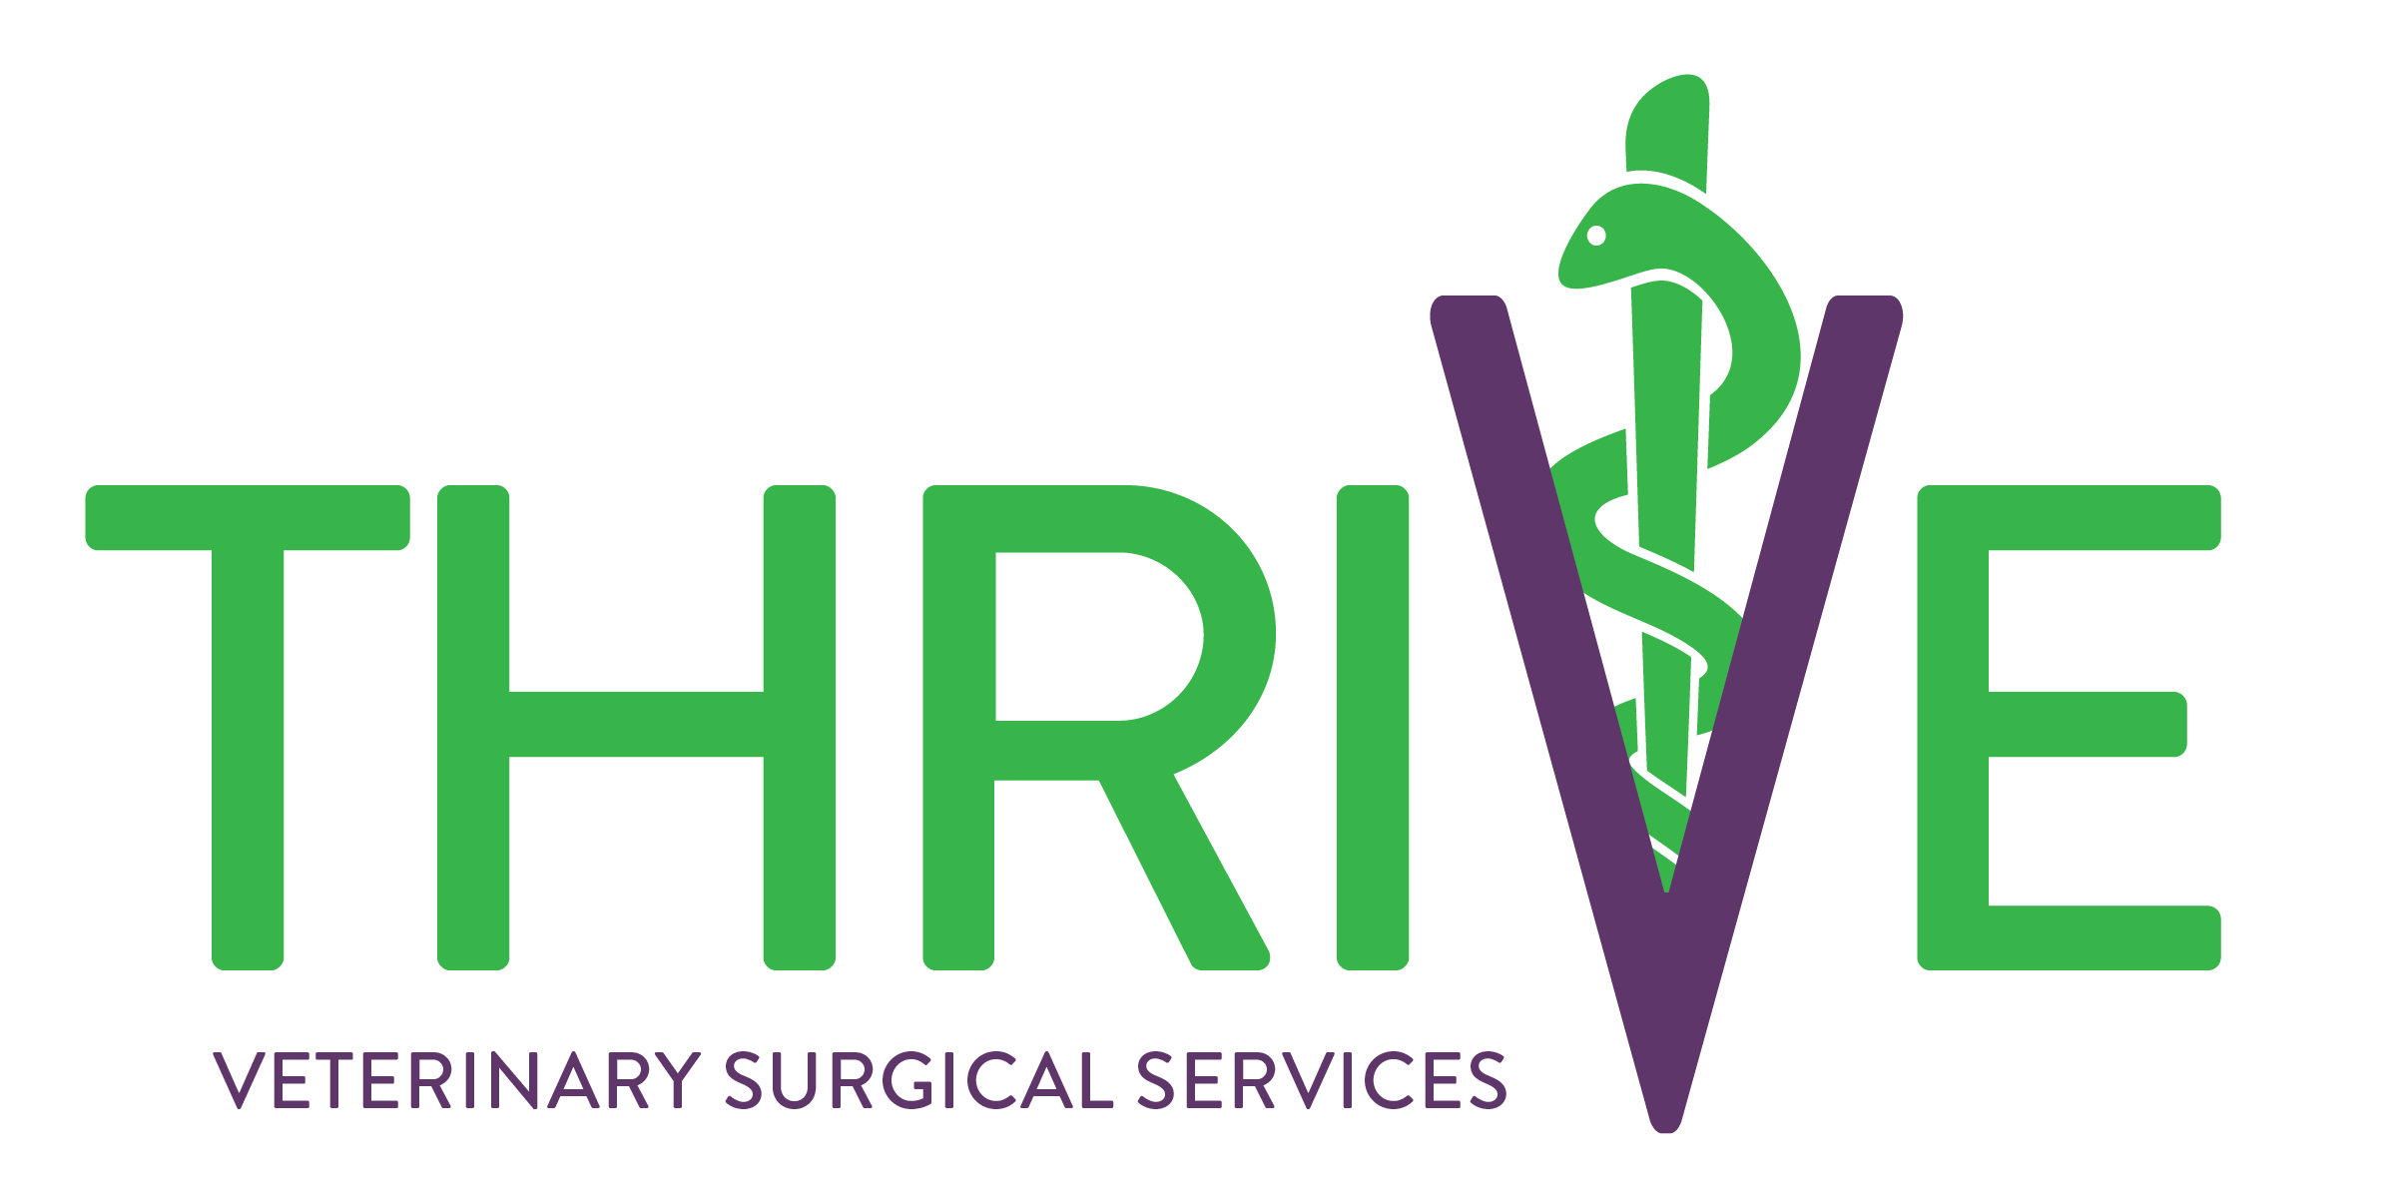

Surgery Consent Form for Thrive Veterinary Surgical Services

TO BE FILLED OUT BY THE CLINIC:

Date: _____________________ Primary veterinarian: ____________________________________________

Owner Name: ______________________________________________________

Pet Name: _________________________________________________________

Signalment: __________________________________________ Today’s weight (kg): __________________

Procedure(s) to be performed: ________________________________________________________________

TO BE FILLED OUT BY THE PET OWNER:

Best phone number(s) to reach you at: __________________________________________________________

Fasted: Yes No Known allergies/drug reactions: ________________________________________

List all current medications (name, dose, frequency, last given): ______________________________________

__________________________________________________________________________________________

__________________________________________________________________________________________

__________________________________________________________________________________________

Surgical consent:
I am the owner, or authorized individual, responsible for seeking veterinary care for the pet identified above and I have the authority to execute this consent. My signature below certifies that I am eighteen years of age or over. The information provided above is accurate to the best of my knowledge.
Anesthesia: While all types of anesthesia involve risks, major side-effects and complications are uncommon. A pet's overall health, age, and unique responses to anesthetic drugs can impact their anesthetic experience. Unexpected situations can occur despite proper anesthetic protocols and monitoring. Complications of anesthesia may include, but are not limited to, hypothermia, extremely low or high blood pressure, corneal ulceration, unexpected drug reactions, tracheal injury, esophagitis, blood clot formation, lung injury, aspiration pneumonia, and death.
Procedure: I have been informed that while a satisfactory result is expected, all surgical procedures carry a risk of complications, unsuccessful results, iatrogenic injury, or even death, from both known and unforeseen causes. I understand that there is no certainty that my pet will achieve all the surgical benefits previously discussed and no guarantee has been made regarding outcome. I further understand that unforeseen situations may arise during surgery that necessitate the performance of additional procedures as deemed necessary by the veterinarian.
I authorize the use of appropriate anesthesia and medical treatment as needed before, during, and after the procedure and have been informed that there are risks associated with the use of any medication.
The nature of these procedures has been explained to me and I understand what will be done. I have been encouraged and given the opportunity to discuss any questions I may have regarding my pet's medical care and my questions have been answered to my satisfaction. I accept that my financial obligations remain regardless of the outcome. I understand that the surgical estimate written above does not include pre- and post-operative care provided by my primary veterinarian. I also understand that it is an estimated quote and that there is a possibility of incurring additional surgical costs.
I have read and understand this authorization and hereby accept and agree to the terms of this consent form.

Resuscitation wishes:
If unexpected cardiopulmonary arrest occurs during surgery, you will be contacted as soon as possible. However, prior consent is needed for resuscitative efforts (CPR) to be initiated before you can be reached. By consenting to this service, you are also acknowledging that certain fees will apply. If you are not able to be contacted immediately, resuscitation efforts will continue to be performed at the doctor's discretion. Please initial your choice below.
________ Yes, perform CPR in the case of arrest.
________ No, do not perform CPR in the case of arrest.

Post-Operative Expectations:
I have been informed, and understand, that my primary veterinarian is responsible for all post-operative care and recheck recommendations. Specific discharge instructions related to my pet’s surgery will be provided to my primary veterinarian by Dr. Serratore, but final recommendations, and subsequent recheck examinations, are at the discretion of my primary veterinarian unless otherwise specified by Dr. Serratore.

____________________________________________________________
Owner signature/date

